**OPEN-PROJ**

**INFORMATION**

**OpenProj** is an [open source](http://en.wikipedia.org/wiki/Open_source) [project management software](http://en.wikipedia.org/wiki/Project_management_software) application. It intends to be a complete desktop replacement for[Microsoft Project](http://en.wikipedia.org/wiki/Microsoft_Project). It runs on the [Java platform](http://en.wikipedia.org/wiki/Java_(software_platform)), allowing it to run on a variety of different [operating systems](http://en.wikipedia.org/wiki/Operating_system).[[1]](http://en.wikipedia.org/wiki/OpenProj#cite_note-IW200710-1)

The current version includes the following features:

* [Earned Value](http://en.wikipedia.org/wiki/Earned_value_management) costing
* [Gantt chart](http://en.wikipedia.org/wiki/Gantt_chart)
* [PERT](http://en.wikipedia.org/wiki/Program_Evaluation_and_Review_Technique) graph
* [Resource Breakdown Structure](http://en.wikipedia.org/wiki/Resource_Breakdown_Structure) (RBS) chart
* Task usage reports
* [Work Breakdown Structure](http://en.wikipedia.org/wiki/Work_Breakdown_Structure) (WBS) chart[[1]](http://en.wikipedia.org/wiki/OpenProj#cite_note-IW200710-1)

Comparison to Microsoft Project

Compared to Microsoft Project, which it closely emulates, OpenProj has a similar user interface (UI), and a similar approach to construction of a project plan: create an indented task list or work breakdown structure (WBS), set durations, create links (either by (a) mouse drag, (b) selection and then button-down, or (c) manually type in the 'predecessor' column), assign resources. The columns (fields) are the same as for Microsoft Project. Users of either software should be broadly comfortable using the other. Costs are the same: labour, hourly rate, material usage, and fixed costs: these are all provided.

However, there are small differences in the UI (comments apply to version 1.4), which take some adaptation for those familiar with Microsoft Project, i.e. OpenProj can't link upwards with method (c), inserting tasks is more difficult than in Microsoft Project, and OpenProj can't create resources on the fly (have to create them first in the resource sheet). There are also several more serious limitations with OpenProj, the chief of these being the unavailability of more detailed views and reports typical of Microsoft Project. For example, though the fields exist for cost, there is no quick way to show them other than to manually insert them. This requires a relatively advanced user: someone who knows what the fields might be called and how to use them.

**DOWNLOAD LINK**

<http://sourceforge.net/projects/openproj/>

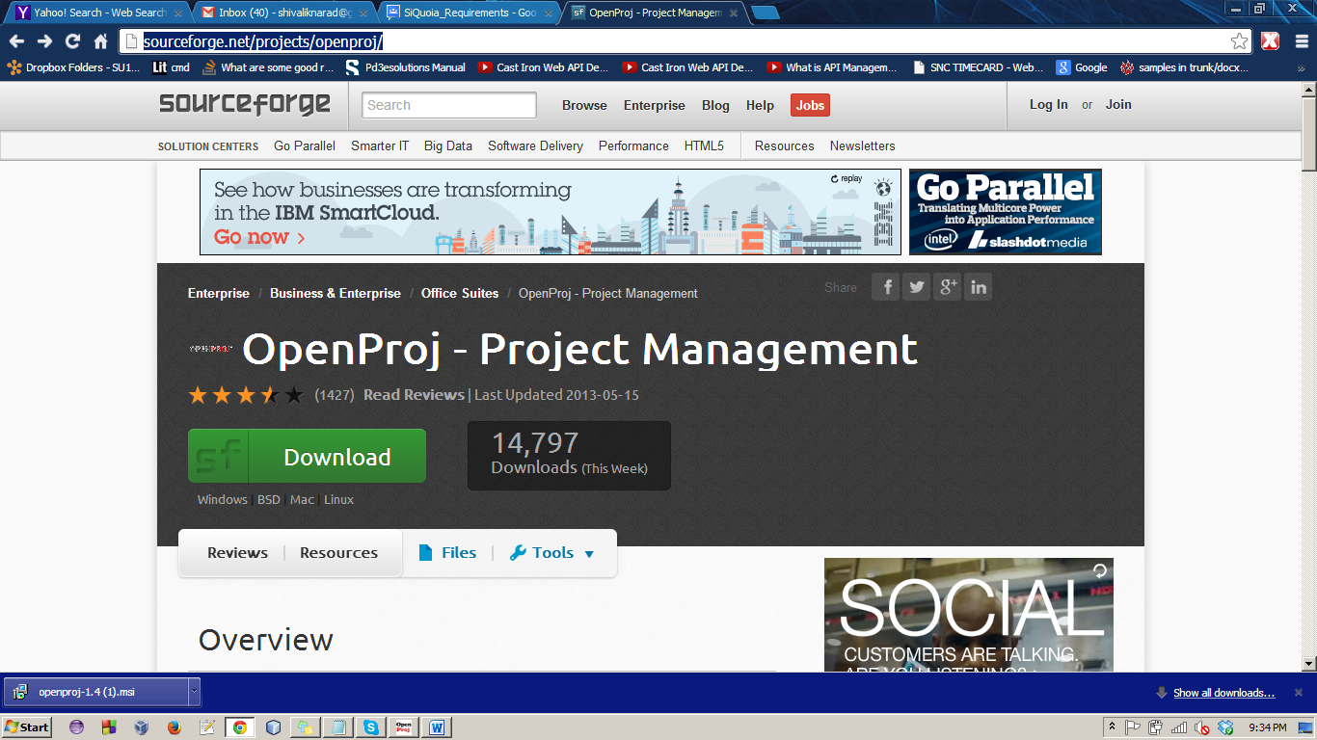

**INSTALLATION INSTRUCTIONS**

Step 1 – Double click and open the downloaded file. A dialog box will appear.

Step 2 – Hit run button on the dialog box.

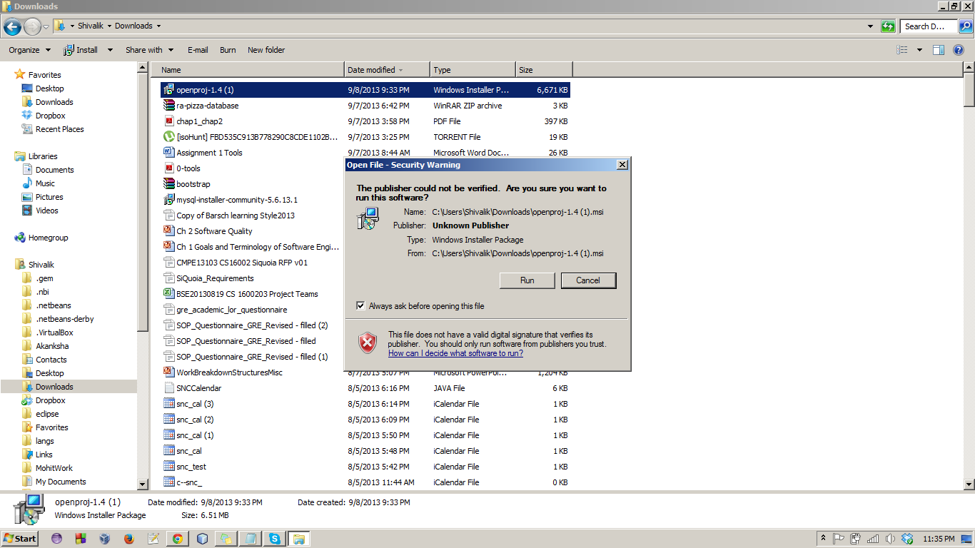

Step 2 – Click next

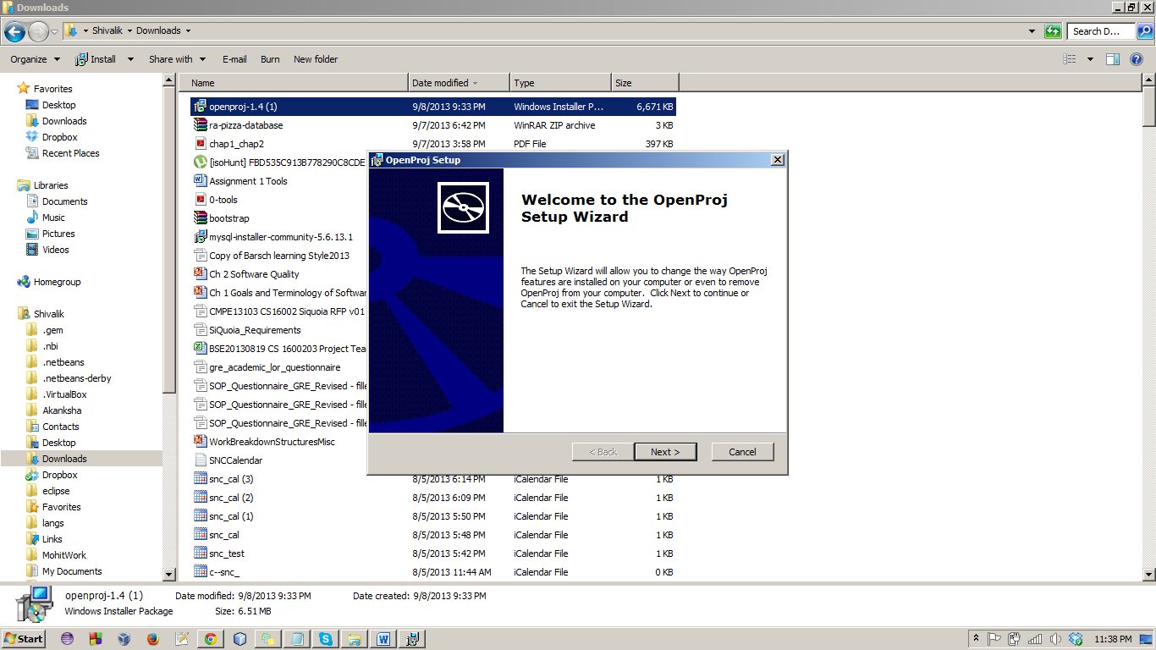

Step 3 – Choose the directory where you want to install. And click next.

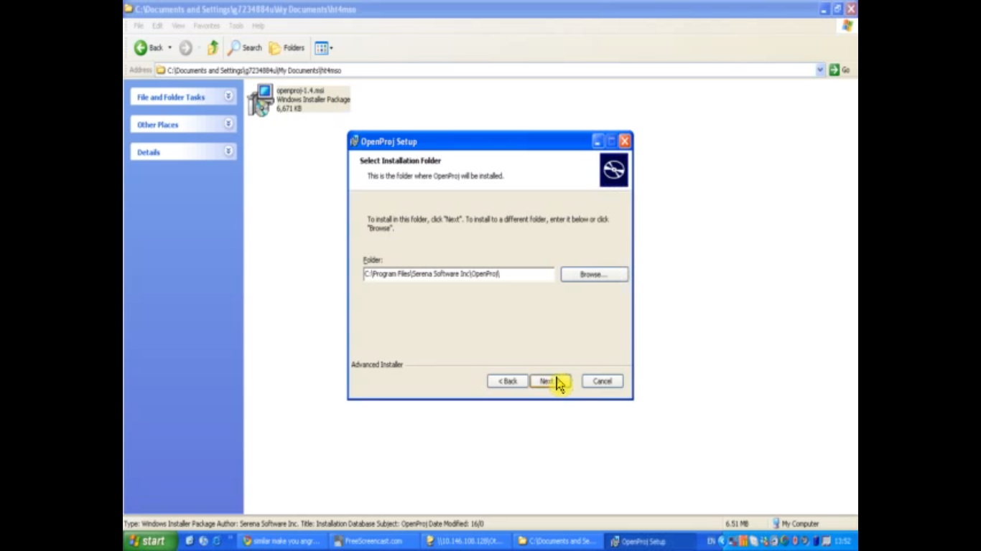

Step 4 – click install

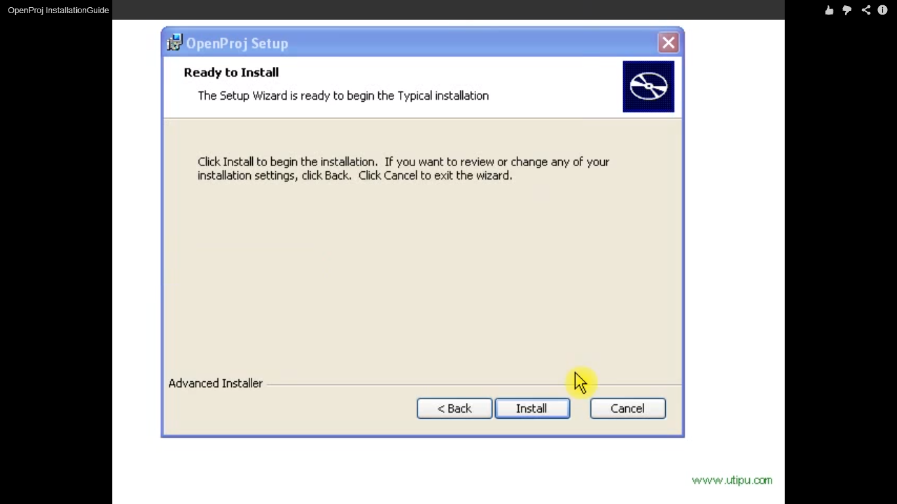

Step 5 – click Finish. And your installation will be complete.

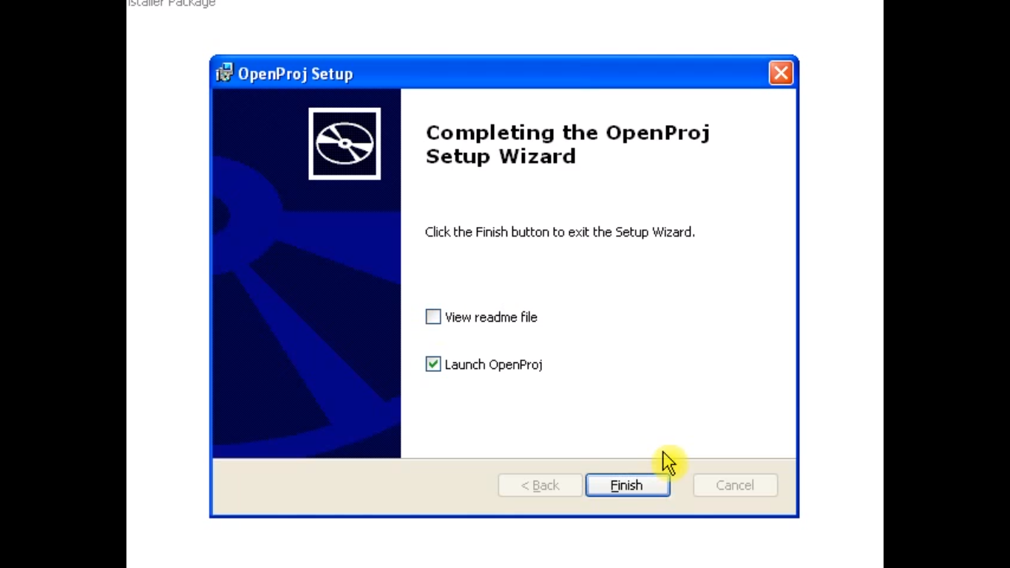

**AFTER INSTALLATION and OPENING OPEN-PROJ**

Step 1 – Click on create Project

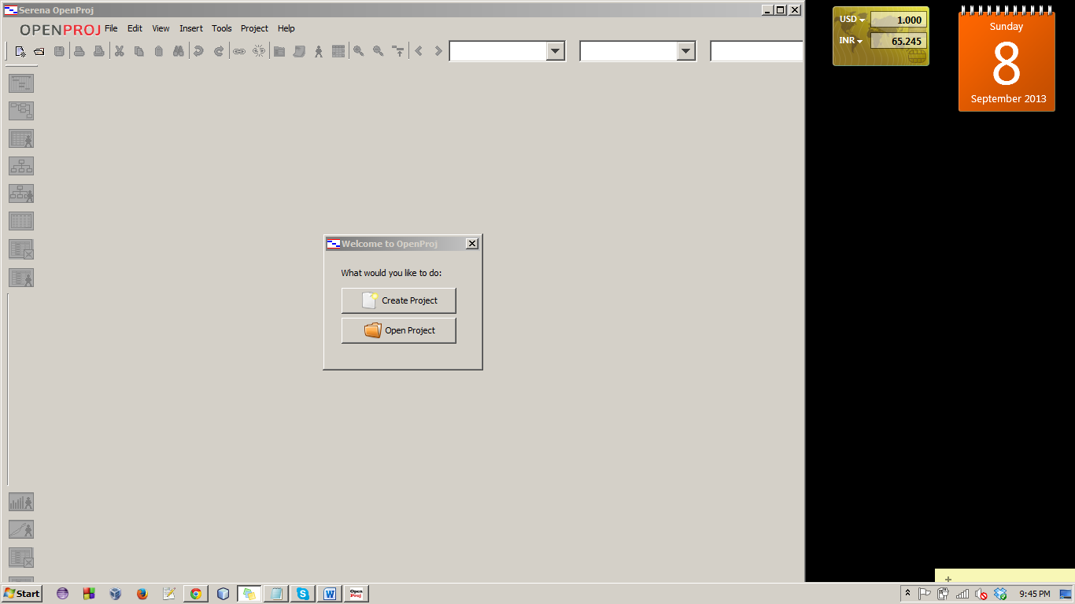

Step 2 – Enter project name, Manager name, Start Date

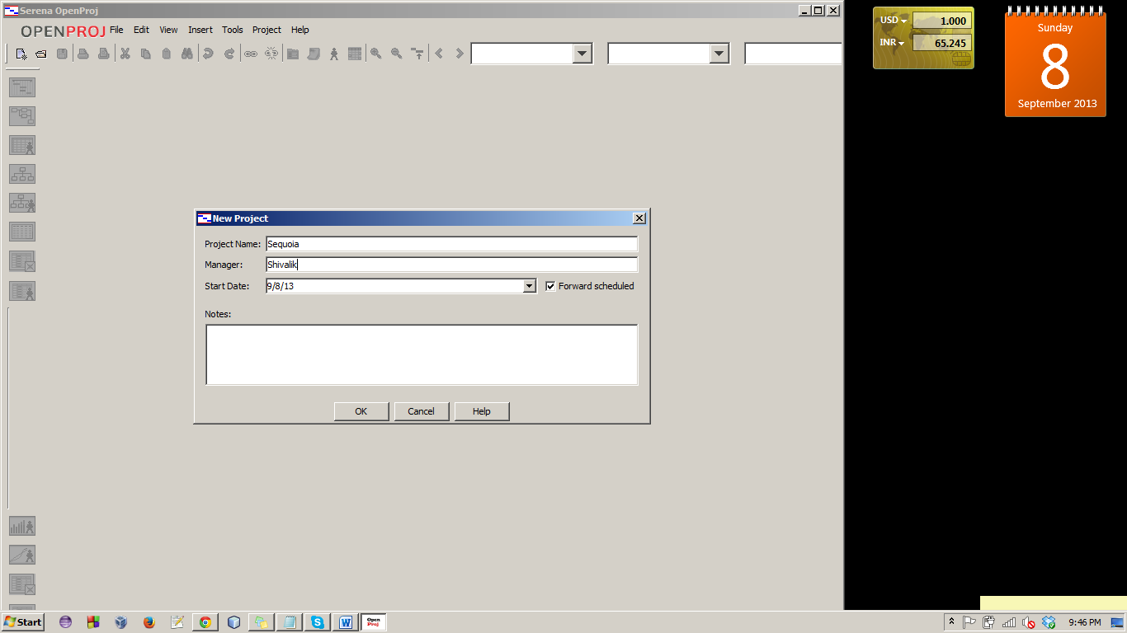

Step 3 – You will get empty table as follow

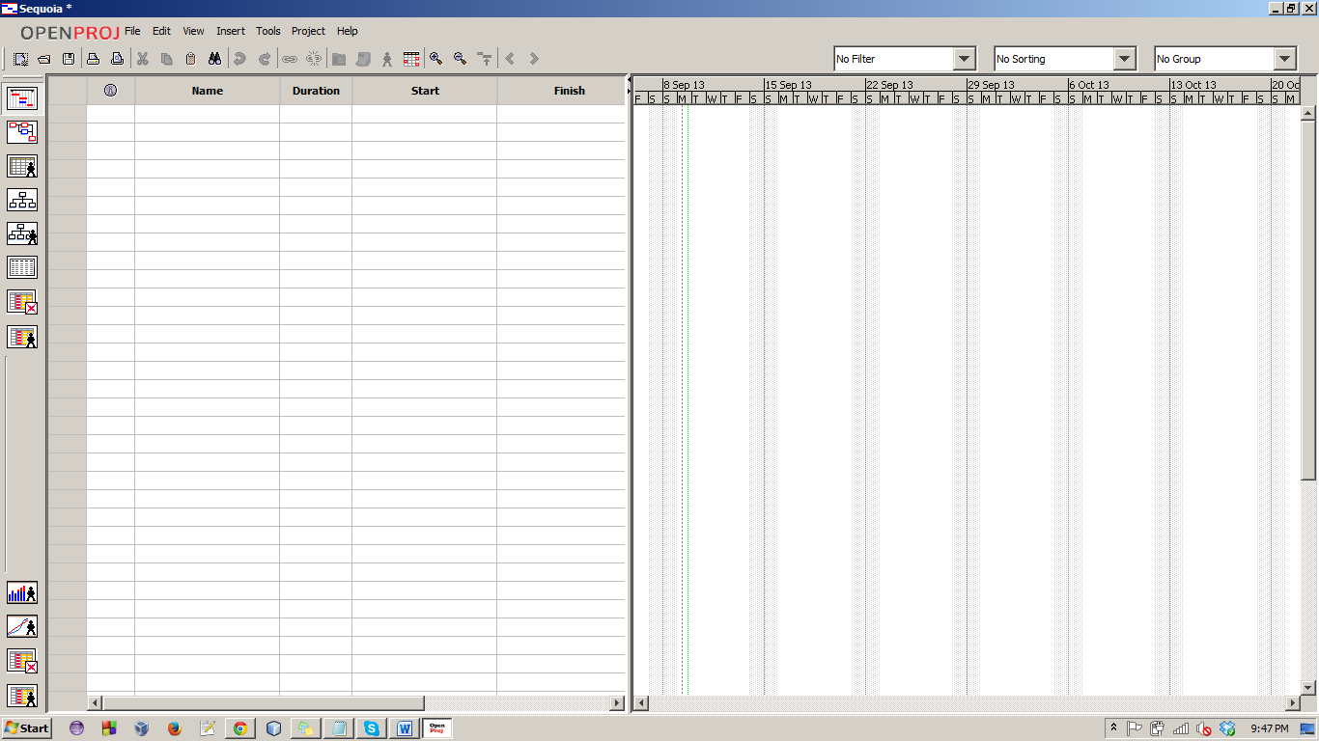

**SAMPLE PROJECT SCHEDULE**

Simply start entering the values in the table and the chart will get created automatically

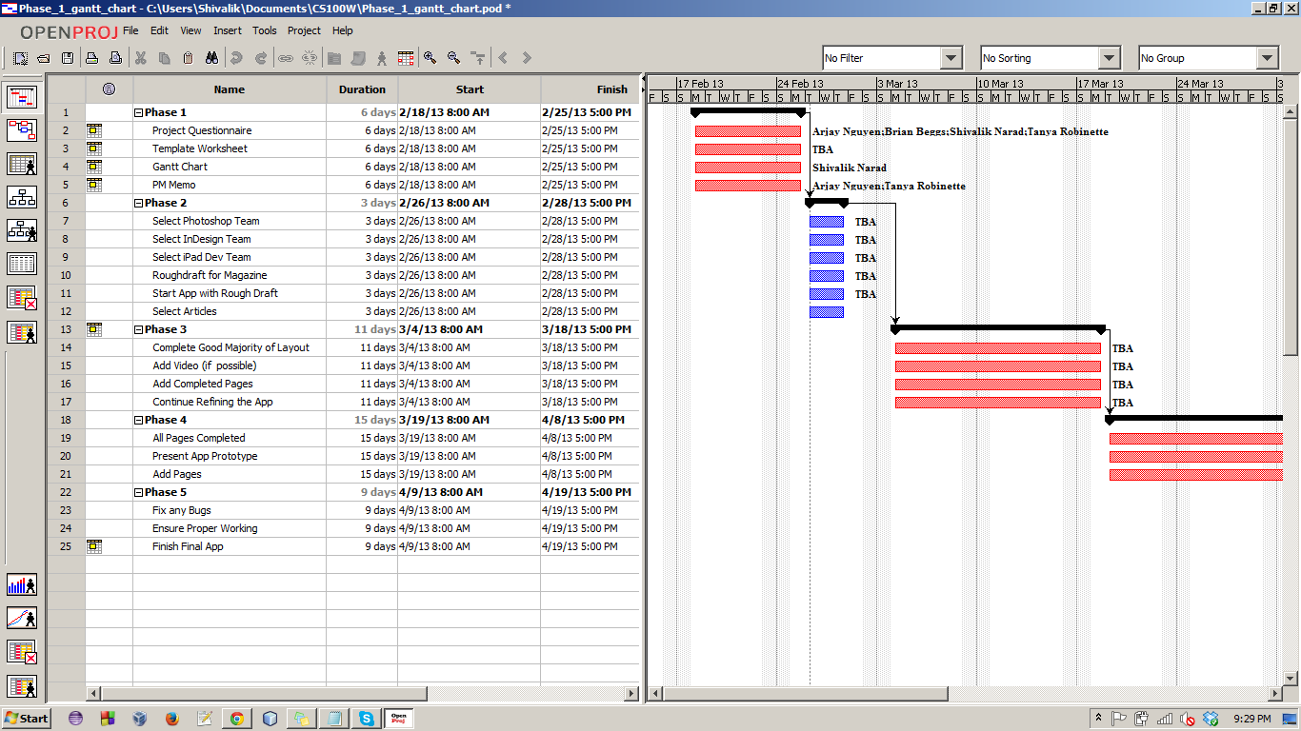

Screenshot of Gantt-Chart showing a sample schedule for a sample project.

It tells us about how the task is divided among the teams. It also tells us about the approximate time task will take to get completed.